**Cedefop’s work presented at regional policy dialogue event in Myanmar**

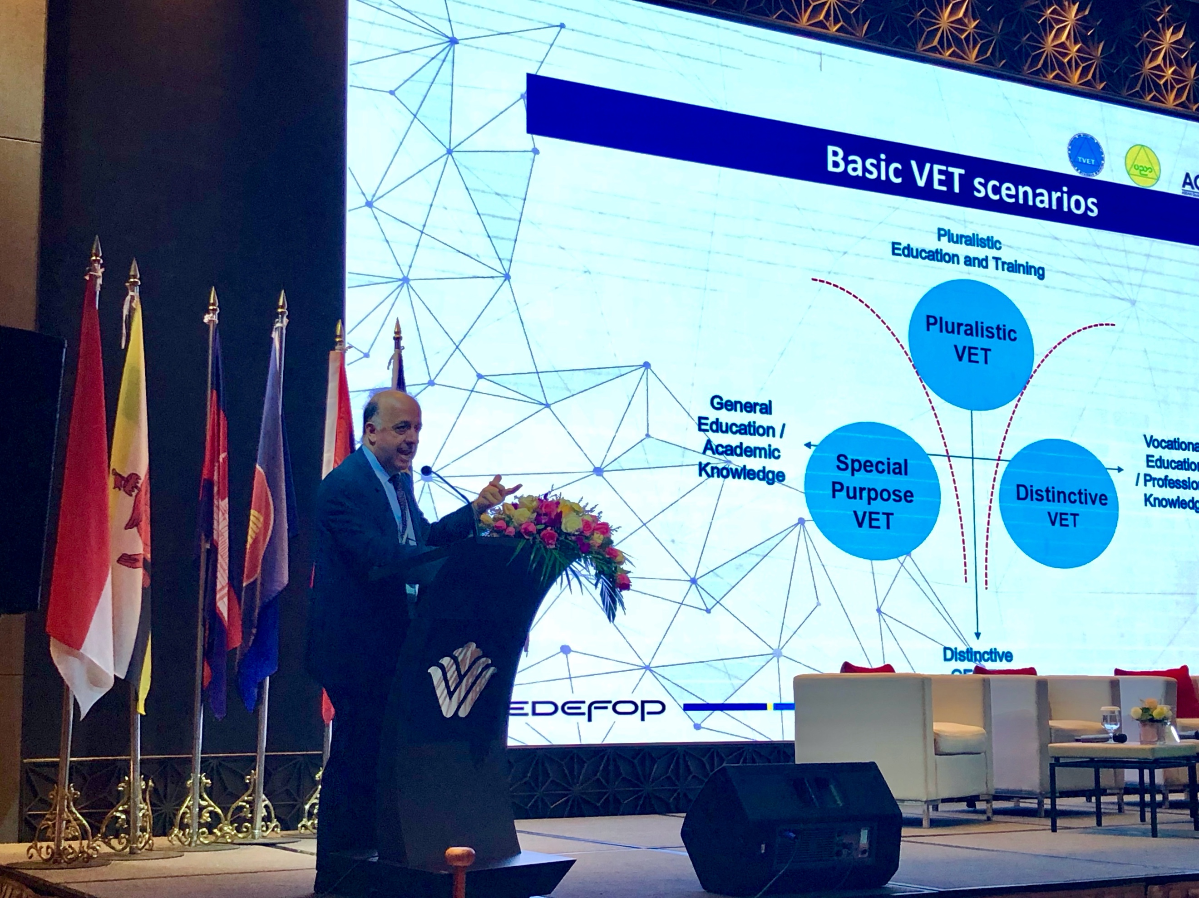

**Image copyright:**

© Nguyen Thuy Hang

**Cooperation on qualifications and quality frameworks is a global priority. To address the importance of quality improvement at this level, the Regional Cooperation in Technical and Vocational Education and Training (RECOTVET) organised the 10th Regional Policy Dialogue on TVET, on 14 and 15 November, in Yangon, Myanmar.**

The conference was organised in cooperation with GIZ (Germany's leading provider of international cooperation services), the Ministry of Education of Myanmar and the ASEAN Quality Assurance Network.

Vocational education and training (VET) systems, skills and qualifications, quality, the role of VET providers and the future of VET were discussed. More than 100 high-level policy-makers, experts and stakeholders from the ASEAN region, Australia, Germany and Switzerland got together to exchange views, share national strategies and experience to support the development of a global perspective for TVET.

Officials from 10 South East Asian countries signed the Yangon declaration committing to enhanced cooperation in TVET.

Cedefop Head of Department for VET Systems and Institutions Loukas Zahilas delivered a keynote speech and participated in a panel discussion. Mr Zahilas presented Cedefop’s work on monitoring European policy developments, the experiences from the cooperation with the EU associations of learning providers and the future of VET.

He also outlined Cedefop’s projects with an international dimension, namely the global inventory of national qualification networks, the global handbook on learning outcomes, comparing VET qualifications and the world reference levels. He mentioned, as an example of the way forward for the region, that European cooperation and policies more and more appear as addressing a range of major dimensions in which countries have managed to make substantial progress, through developing coordinated and converging actions and the exchange of good practices and experiences. Although the challenges remain, working together is the best way to achieve concrete results, he concluded.